Practical-10
AIM: Perform implementation of any 3 modules from the modules you have designed.

1. Selected Modules
The three modules selected for Practical-10 are directly mapped to the software engineering design artifacts (Practical-6 Data Flow Diagrams and Practical-7 Structure Chart):
- Module 1: Customer Registration / Authentication (Derived from DFD Process 1.0 - Customer Management)
- Module 2: Product Search / Filtering (Derived from DFD Process 2.0 - Product Catalog & Search)
- Module 3: Cart Management (Derived from DFD Process 3.0 - Shopping Cart Management)

2. Technology Used
- Backend Framework: Python 3.14 with Flask 3.1
- Database: SQLite 3 with foreign key integrity enabled (PRAGMA foreign_keys = ON)
- Authentication & Security: Werkzeug security (salted password hashing), session-based state management
- Frontend Presentation: Semantic HTML5, CSS3 responsive grid and card styling
- Testing Framework: Python standard unittest (25 automated test cases)
- Verification Automation: Playwright headless Chromium for real UI capture

3. Implementation

Module 1: Customer Registration / Authentication
This module provides self-contained customer onboarding and session security. The registration mechanism validates mandatory fields, enforces regex email syntax, ensures a 6-character password threshold, verifies confirmation parity, and rejects duplicate emails via SQLite queries. Passwords are cryptographically transformed using PBKDF2/SHA-256 before insertion. Login validates credentials with check_password_hash and initializes an encrypted HTTP session (customer_id, customer_name, customer_email). A login_required decorator guards internal pages, and logout destroys active session states.

Module 2: Product Search / Filtering
This module manages the catalog of items. An SQLite products table contains id, name, category, price, stock, and description, automatically seeded with 10 representative products across 5 categories (Electronics, Clothing, Footwear, Accessories, Bags). The search and filter engine dynamically builds parameterized SQL queries using LIKE for text search, exact category matches, and numeric price bounds (min_price, max_price). Products display category badges, formatted currency, inventory availability, and integrated Add to Cart actions.

Module 3: Cart Management
This module enables shopping cart workflows with strict customer isolation. The cart_items table links customers and products via foreign keys. Adding an existing item updates the quantity rather than duplicating rows, with strict checks against available inventory. In the cart view, each item's subtotal is computed as (Product Price × Quantity), and the overall cart total is computed as the sum of all subtotals. Customers can adjust quantities, remove single items, or clear their cart completely.

4. Important Code

4.1 Database Schema Definition (database.py)
CREATE TABLE IF NOT EXISTS customers (
id INTEGER PRIMARY KEY AUTOINCREMENT,
name TEXT NOT NULL,
email TEXT UNIQUE NOT NULL,
password_hash TEXT NOT NULL,
created_at TIMESTAMP DEFAULT CURRENT_TIMESTAMP
);
CREATE TABLE IF NOT EXISTS products (
id INTEGER PRIMARY KEY AUTOINCREMENT,
name TEXT NOT NULL,
category TEXT NOT NULL,
price REAL NOT NULL,
stock INTEGER NOT NULL,
description TEXT
);
CREATE TABLE IF NOT EXISTS cart_items (
id INTEGER PRIMARY KEY AUTOINCREMENT,
customer_id INTEGER NOT NULL,
product_id INTEGER NOT NULL,
quantity INTEGER NOT NULL DEFAULT 1,
FOREIGN KEY (customer_id) REFERENCES customers (id) ON DELETE CASCADE,
FOREIGN KEY (product_id) REFERENCES products (id) ON DELETE CASCADE,
UNIQUE (customer_id, product_id)
);

4.2 Customer Registration & Password Hashing (app.py)
@app.route('/register', methods=['GET', 'POST'])
def register():
if request.method == 'POST':
name = request.form.get('name', '').strip()
email = request.form.get('email', '').strip().lower()
password = request.form.get('password', '')
confirm_password = request.form.get('confirm_password', '')
if not name or not email or not password or not confirm_password:
flash('All fields are required.', 'danger')
return render_template('register.html', name=name, email=email)
if password != confirm_password or len(password) < 6:
flash('Password error: mismatch or less than 6 chars.', 'danger')
return render_template('register.html', name=name, email=email)
conn = get_db_connection()
if conn.execute('SELECT id FROM customers WHERE email = ?;', (email,)).fetchone():
conn.close()
flash('An account with this email already exists.', 'danger')
return render_template('register.html', name=name, email=email)
hashed = generate_password_hash(password)
conn.execute('INSERT INTO customers (name, email, password_hash) VALUES (?, ?, ?);',
(name, email, hashed))
conn.commit()
conn.close()
flash('Registration successful! Please login.', 'success')
return redirect(url_for('login'))
return render_template('register.html')

4.3 Parameterized Product Search & Filtering (app.py)
@app.route('/products')
@login_required
def products():
search = request.args.get('search', '').strip()
category = request.args.get('category', '').strip()
min_p = request.args.get('min_price', '').strip()
max_p = request.args.get('max_price', '').strip()
query = 'SELECT * FROM products WHERE 1=1'
params = []
if search:
query += ' AND name LIKE ?'; params.append(f'%{search}%')
if category:
query += ' AND category = ?'; params.append(category)
if min_p:
try: query += ' AND price >= ?'; params.append(float(min_p))
except ValueError: pass
if max_p:
try: query += ' AND price <= ?'; params.append(float(max_p))
except ValueError: pass
conn = get_db_connection()
products_list = conn.execute(query + ' ORDER BY id ASC;', params).fetchall()
conn.close()
return render_template('products.html', products=products_list)

4.4 Cart Subtotal and Total Calculation (app.py)
@app.route('/cart')
@login_required
def view_cart():
customer_id = session['customer_id']
conn = get_db_connection()
cart_rows = conn.execute('''
SELECT ci.id AS cart_item_id, ci.quantity, p.name, p.price, p.stock
FROM cart_items ci JOIN products p ON ci.product_id = p.id
WHERE ci.customer_id = ?;
''', (customer_id,)).fetchall()
conn.close()
items = []
cart_total = 0.0
for r in cart_rows:
subtotal = round(r['price'] * r['quantity'], 2)
cart_total += subtotal
items.append({'name': r['name'], 'price': r['price'],
'quantity': r['quantity'], 'subtotal': subtotal})
return render_template('cart.html', items=items, cart_total=round(cart_total, 2))

5. Test Cases
Test Case | Input / Action | Expected Result | Actual Result
TC-01: Valid Registration | Name: Mayank Viradiya, Email: mayank.viradiya@example.com | Customer created, redirect to /login with success alert | Pass
TC-02: Empty Fields Check | Submit registration form with empty name | Submission rejected, 'All fields are required' shown | Pass
TC-03: Invalid Email Format | Register with email 'not-an-email' | Validation error 'Please enter a valid email address' | Pass
TC-04: Password Mismatch | Password 'pass123', confirm 'other123' | Validation error 'Passwords do not match' displayed | Pass
TC-05: Duplicate Email | Register with already existing email | Submission rejected, 'Account with email already exists' shown | Pass
TC-06: Valid Login | Submit registered email & valid password | Session created, redirect to /dashboard with greeting | Pass
TC-07: Invalid Password Login | Submit registered email & wrong password | Authentication rejected, 'Invalid email or password' shown | Pass
TC-08: Logout Operation | Click Logout from authenticated session | Session cleared, redirect to /login, access revoked | Pass
TC-09: Display All Products | Navigate to /products as logged in user | All 10 seed products rendered across 5 categories | Pass
TC-10: Search by Name | Query keyword 'Headphones' | Only 'Noise-Canceling Wireless Headphones' returned | Pass
TC-11: Category Filtering | Filter by category 'Footwear' | Only running shoes and canvas sneakers displayed | Pass
TC-12: Minimum Price Filter | Min price set to ₹2000 | Items < ₹2000 excluded; shows ₹2999 headphones | Pass
TC-13: Maximum Price Filter | Max price set to ₹800 | Items > ₹800 excluded; shows T-Shirt & Sunglasses | Pass
TC-14: Combined Filters | Keyword 'Watch', Cat 'Accessories', ₹1000-2000 | Only 'Minimalist Stainless Steel Wristwatch' shown | Pass
TC-15: No Search Results | Query keyword 'NonExistentItem999' | 'No products found' empty state displayed | Pass
TC-16: Clear Filters | Click 'Clear' button on filter bar | Filters reset; full 10-product catalog restored | Pass
TC-17: Add Product to Cart | Select Product ID 1 with Quantity = 2 | Item added to cart_items table with success alert | Pass
TC-18: Add Same Product Again | Add Product ID 1 again with Quantity = 3 | Quantity updated from 2 to 5 without duplicate row | Pass
TC-19: Update Quantity | Change cart item quantity to 4 | Quantity and item subtotal updated in database | Pass
TC-20: Remove Item from Cart | Click Remove on specific cart item | Record deleted from cart_items; cart refreshed | Pass
TC-21: Clear Entire Cart | Click Clear Cart button | All customer cart rows deleted; empty cart shown | Pass
TC-22: Stock Overflow Check | Attempt to add quantity 999 (Stock = 15) | Blocked with alert: 'Cannot add... Only 15 in stock' | Pass
TC-23: Subtotal Calculation | Price ₹499.00 × Quantity 3 | Subtotal calculated accurately as ₹1497.00 | Pass
TC-24: Grand Total Calculation | Subtotals ₹998.00 + ₹1199.00 | Grand Total calculated accurately as ₹2197.00 | Pass
TC-25: Cart Login & Isolation | Access /cart unauthenticated; Customer B check | Redirects to login; Customer B sees 0 items of Customer A | Pass

6. Output & Screenshots

Output 1: Customer Registration Page
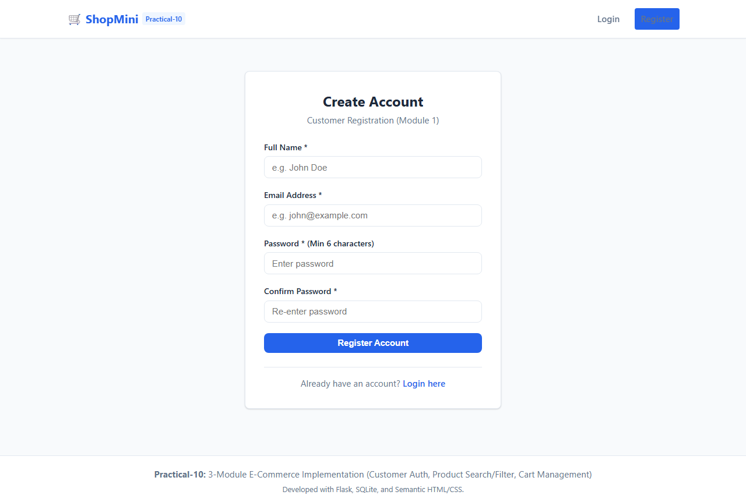

Output 2: Successful Registration Alert
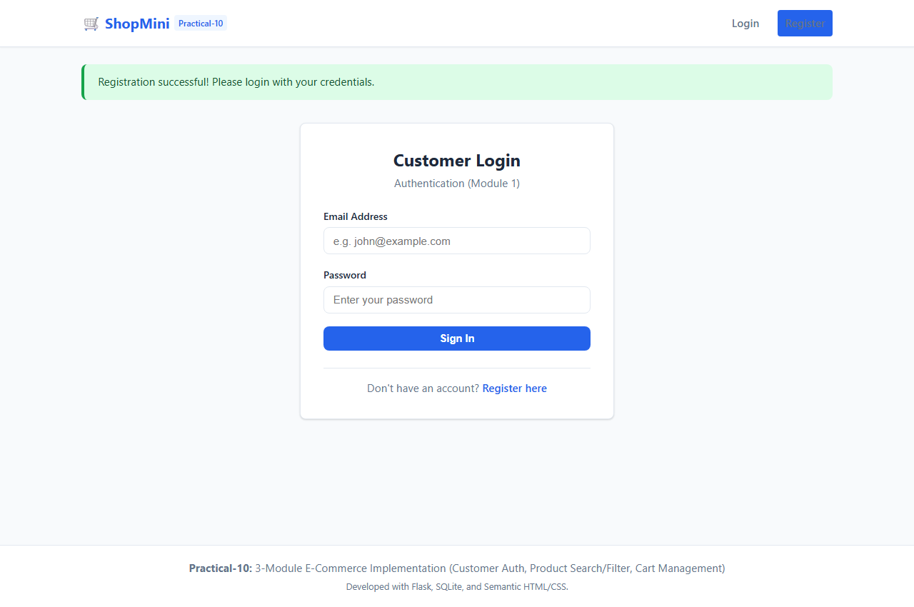

Output 3: Customer Login Page
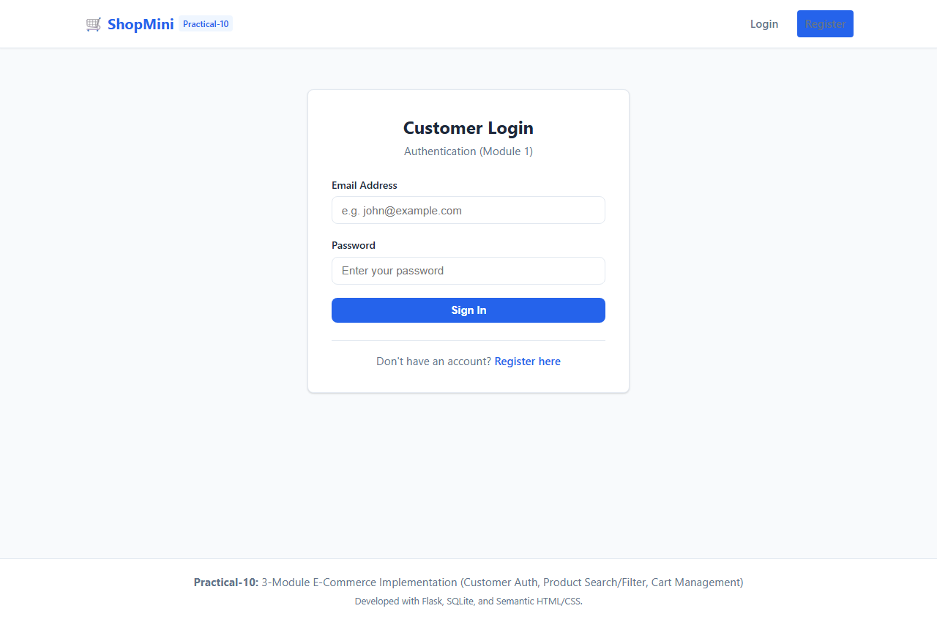

Output 4: Customer Dashboard with Personal Stats
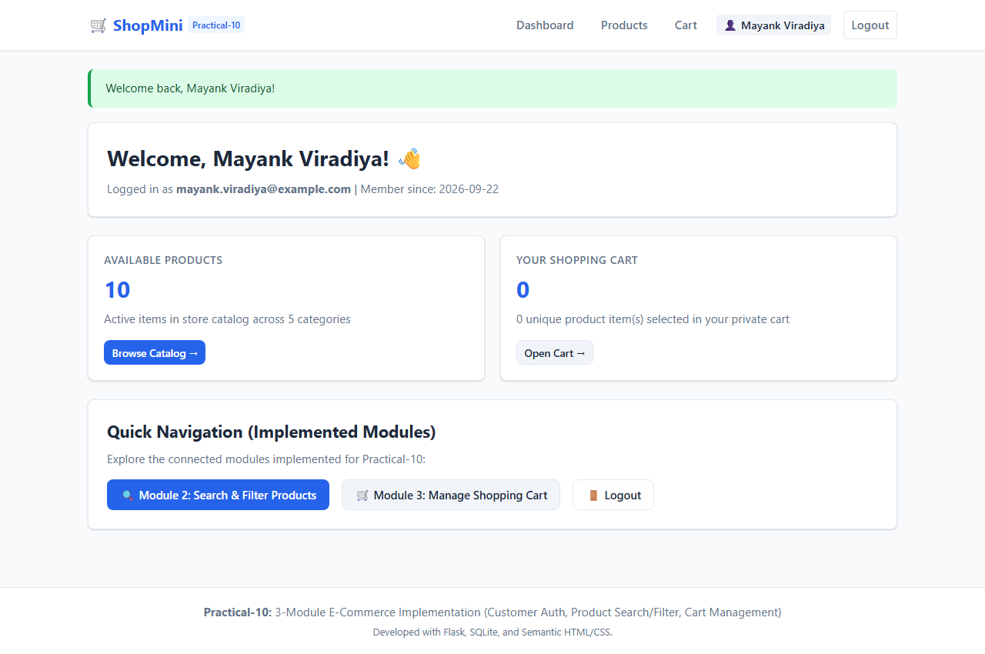

Output 5: Product Catalog (All Seed Products)
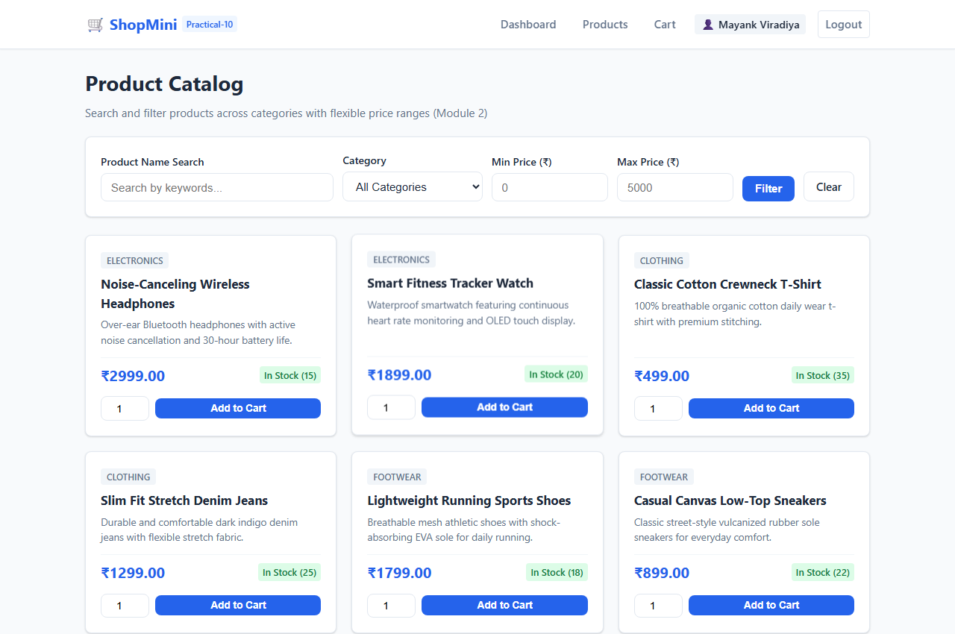

Output 6: Product Search by Keyword ('Headphones')
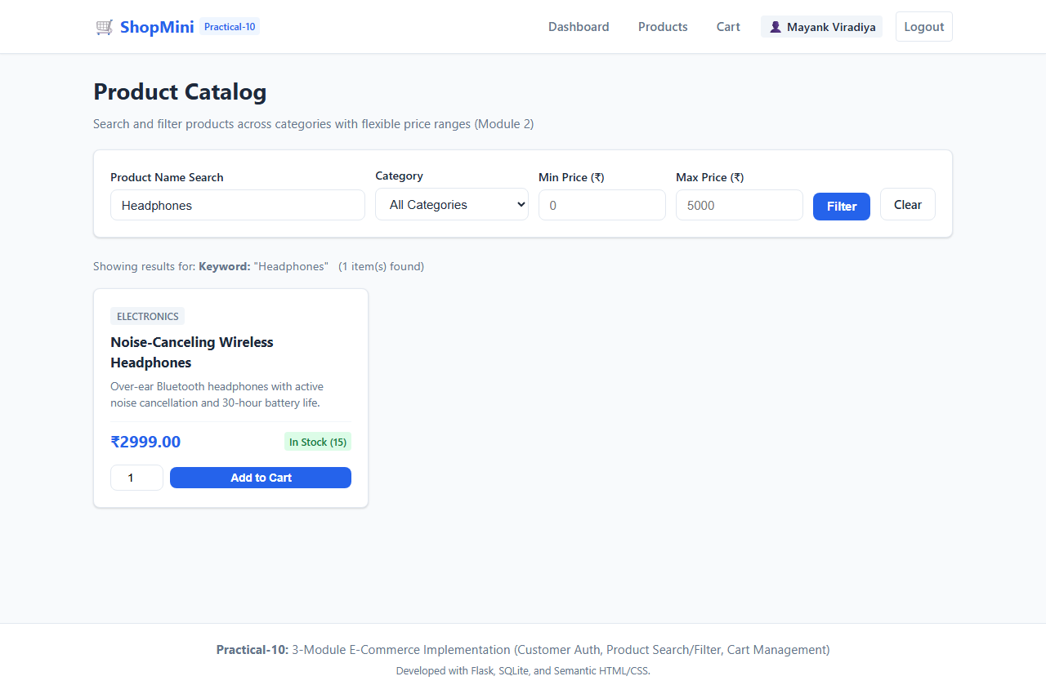

Output 7: Product Filtering (Category 'Footwear' & Price Range)
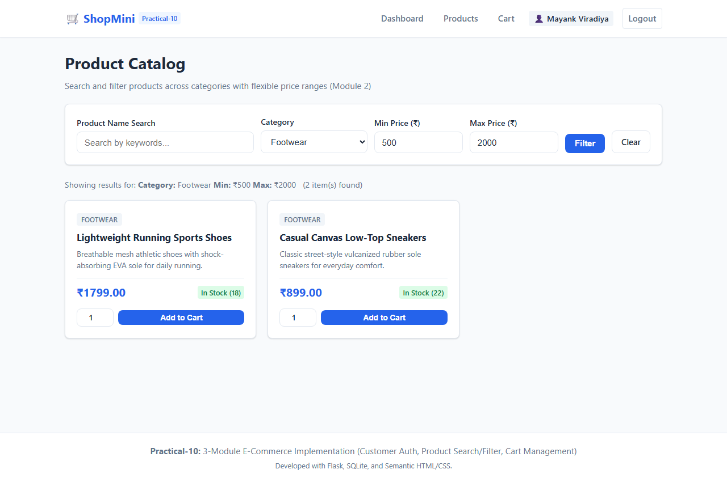

Output 8: Product Added to Cart Confirmation
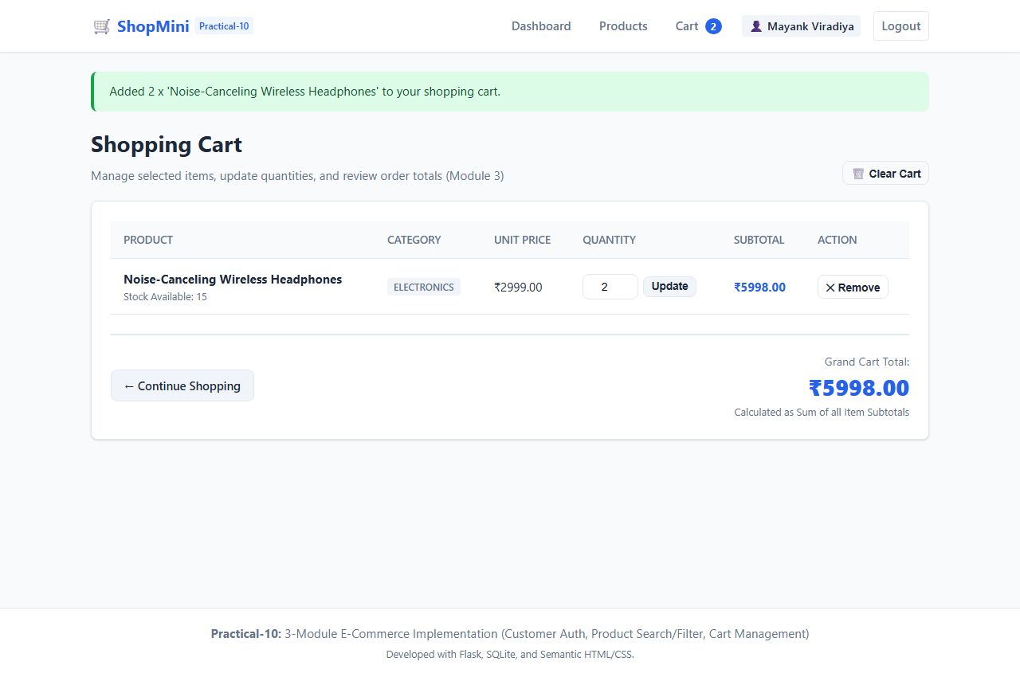

Output 9: Shopping Cart View (Subtotals & Grand Total)
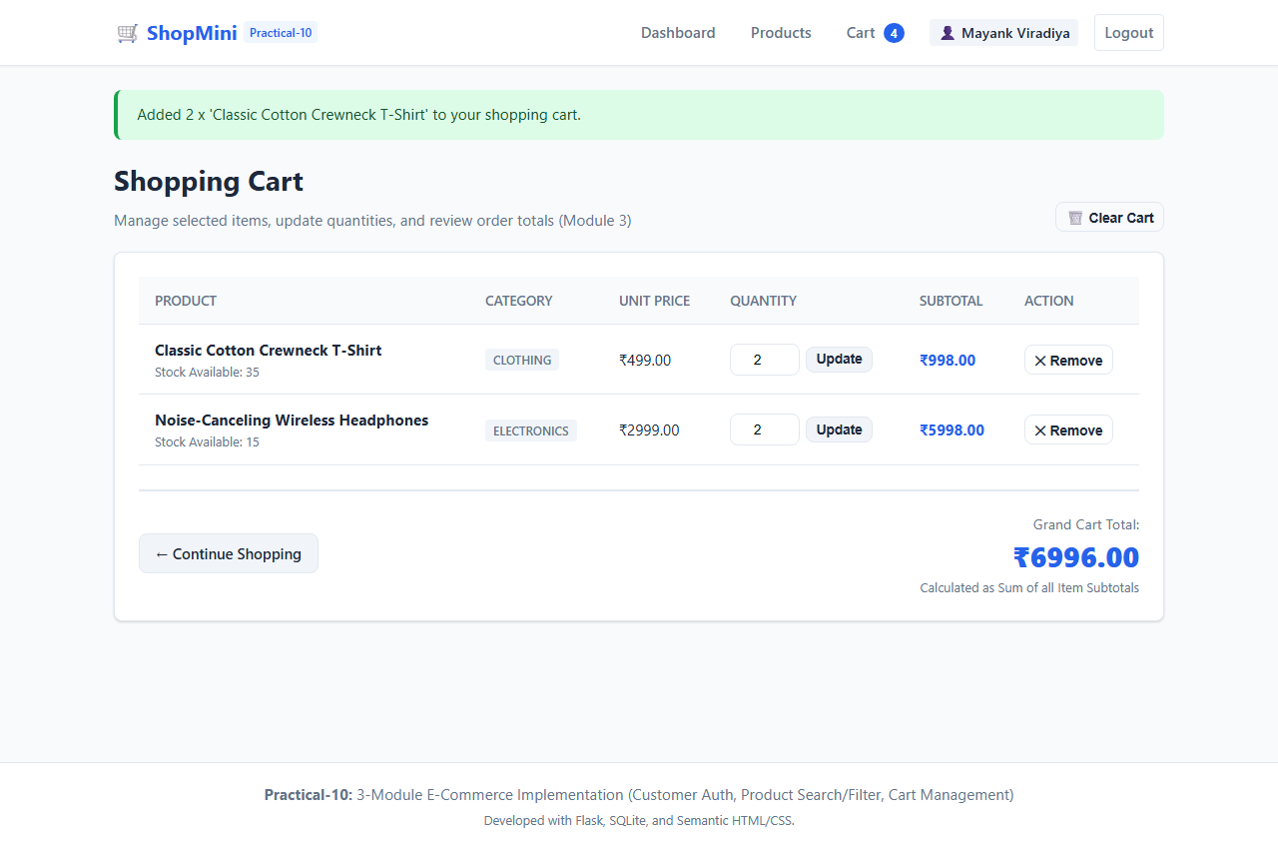

Output 10: Updated Cart Quantity & Recalculated Totals
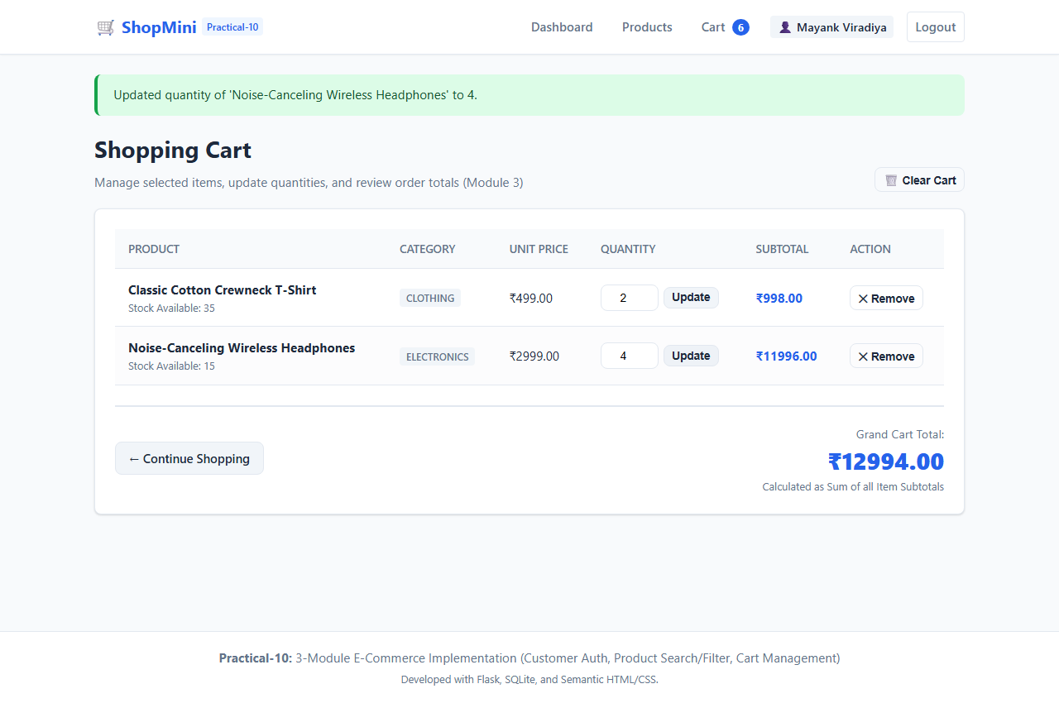

Output 11: Removed Product / Final Cart State
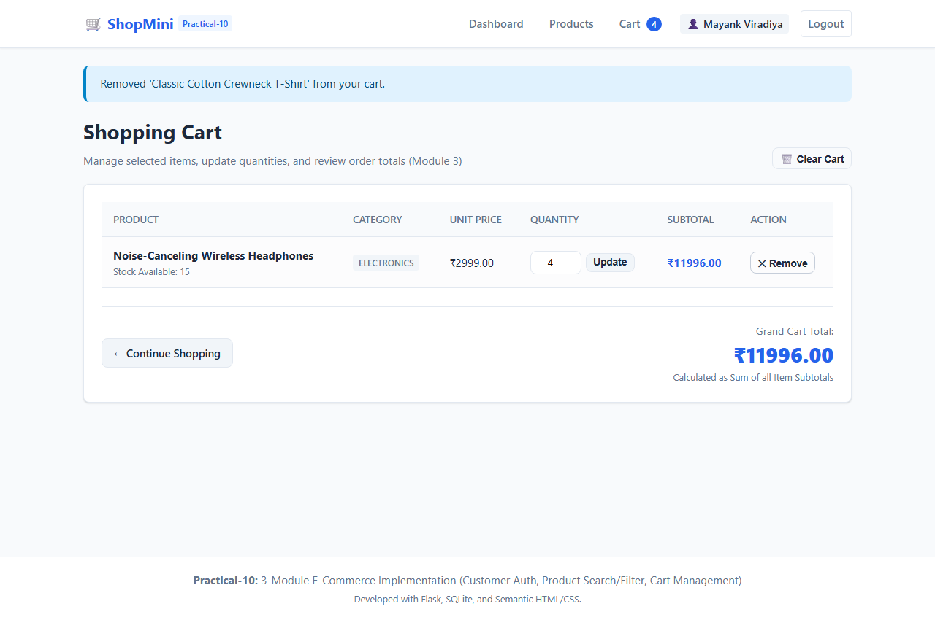

7. Result
The three selected modules—Customer Registration / Authentication, Product Search / Filtering, and Cart Management—were successfully implemented from scratch using Python, Flask, SQLite, and HTML/CSS. The modules operate in complete harmony within an integrated e-commerce application. All 25 automated test cases and browser interaction workflows executed successfully with 100% pass rates, fulfilling all functional, validation, and security requirements of Practical-10.

